

Submitted by : Spogmai Jan
Roll no : 2430 -0081
Submitted to : mam yusra

dsa lab 06
TASK 01:
Write output of the following.
#include<iostream>
using namespace std;
int main(){

int* p = new int;
*p = 25;
cout << *p << endl; int* q;
q = p;
cout << *q<<endl;

}

OUTPUT:
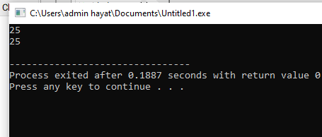

#include<iostream>
using namespace std;
int main(){

int* p = new int(25);
cout << *p << endl;
int* q = p;
cout << *q<<endl;
return 0;

}

OUTPUT:
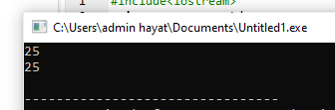
#include <iostream>
using namespace std;

class Car {
public:
int tyres, doors, lights;
};

int main() {
Car* ptr = new Car;

ptr->tyres = 4;
ptr->doors = 4;
ptr->lights = 2;

cout << "Total tyres * 4 = " << ptr->tyres * 4 << endl;

int* p = new int(5);
cout << "Value of *p = " << *p << endl;

delete p;
delete ptr;

p = nullptr;
ptr = nullptr;

cout << "Pointers set to null." << endl;

return 0;
}

OUTPUT:
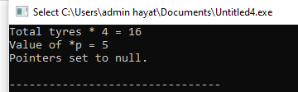
#include <iostream>
using namespace std;

int main() {
int x, n;
cout << "How many numbers will you type?" << endl;
cin >> n;

int *arr = new int[n];

cout << "Enter " << n << " numbers:" << endl;
for (x = 0; x < n; x++) {
cin >> arr[x];
}

cout << "You typed: ";
for (x = 0; x < n; x++) {
cout << arr[x] << " ";
}
cout << endl;

delete[] arr;

return 0;
}

OUTPUT:
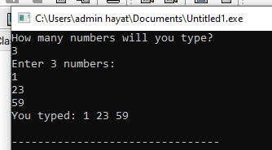

TASK 02: Add a function to find multiple occurrences of data element in the list.
#include <iostream>
#include <vector>
using namespace std;

// Node class
class Node {
public:
int data;
Node* next;

Node(int value) {
data = value;
next = nullptr;
}
};

// LinkedList class
class LinkedList {
private:
Node* head;

public:
LinkedList() {
head = nullptr;
}

// Insert node at end
void insert(int value) {
Node* newNode = new Node(value);
if (!head) {
head = newNode;
return;
}

Node* temp = head;
while (temp->next) {
temp = temp->next;
}
temp->next = newNode;
}

// Display the linked list
void display() const {
Node* temp = head;
while (temp) {
cout << temp->data << " -> ";
temp = temp->next;
}
cout << "NULL" << endl;
}

// Find multiple occurrences of a value
vector<int> findOccurrences(int element) const {
vector<int> positions;
Node* temp = head;
int index = 0;

while (temp) {
if (temp->data == element) {
positions.push_back(index);
}
temp = temp->next;
index++;
}

return positions;
}
};

int main() {
LinkedList list;

// Insert elements into linked list
list.insert(1);
list.insert(2);
list.insert(3);
list.insert(2);
list.insert(4);
list.insert(2);
list.insert(5);

cout << "Linked List: ";
list.display();

int elementToFind = 2;
vector<int> positions = list.findOccurrences(elementToFind);

if (positions.empty()) {
cout << "Element " << elementToFind << " not found in the list." << endl;
} else {
cout << "Element " << elementToFind << " found at positions: ";
for (int pos : positions) {
cout << pos << " ";
}
cout << endl;
}

return 0;
}

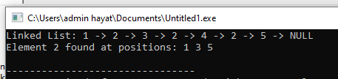
TASK 03:
Write a program to create a list of employees.
a) Create Employee class with data member’s id, name and salary.
b) Add following functions in the list
o insertAtHead()
o insertAtLast()
o displayList()
o DeleteAtHead
o DeleteLast()
o DeleteMid()
o Search().......search on the basis of employee ID.
#include <iostream>
#include <string>
using namespace std;

// Employee class
class Employee {
public:
int id;
string name;
float salary;

Employee(int id = 0, string name = "", float salary = 0.0f) {
this->id = id;
this->name = name;
this->salary = salary;
}
};

// Node class
class Node {
public:
Employee data;
Node* next;

Node(Employee emp) {
data = emp;
next = nullptr;
}
};

// LinkedList class
class EmployeeList {
private:
Node* head;

public:
EmployeeList() {
head = nullptr;
}

// Insert at Head
void insertAtHead(Employee emp) {
Node* newNode = new Node(emp);
newNode->next = head;
head = newNode;
cout << "Employee inserted at head successfully.\n";
}

// Insert at Last
void insertAtLast(Employee emp) {
Node* newNode = new Node(emp);
if (!head) {
head = newNode;
cout << "Employee inserted at end successfully.\n";
return;
}

Node* temp = head;
while (temp->next) {
temp = temp->next;
}
temp->next = newNode;
cout << "Employee inserted at end successfully.\n";
}

// Display all employees
void displayList() const {
if (!head) {
cout << "List is empty.\n";
return;
}

Node* temp = head;
cout << "\nEmployee List:\n";
cout << "------------------------------\n";
while (temp) {
cout << "ID: " << temp->data.id
<< " | Name: " << temp->data.name
<< " | Salary: " << temp->data.salary << endl;
temp = temp->next;
}
cout << "------------------------------\n";
}

// Delete at Head
void deleteAtHead() {
if (!head) {
cout << "List is empty. Nothing to delete.\n";
return;
}
Node* temp = head;
head = head->next;
delete temp;
cout << "Deleted first employee successfully.\n";
}

// Delete at Last
void deleteAtLast() {
if (!head) {
cout << "List is empty. Nothing to delete.\n";
return;
}

if (!head->next) {
delete head;
head = nullptr;
cout << "Deleted last employee successfully.\n";
return;
}

Node* temp = head;
while (temp->next->next) {
temp = temp->next;
}
delete temp->next;
temp->next = nullptr;
cout << "Deleted last employee successfully.\n";
}

// Delete by ID (Middle)
void deleteMid(int empID) {
if (!head) {
cout << "List is empty.\n";
return;
}

if (head->data.id == empID) {
deleteAtHead();
return;
}

Node* temp = head;
while (temp->next && temp->next->data.id != empID) {
temp = temp->next;
}

if (!temp->next) {
cout << "Employee with ID " << empID << " not found.\n";
return;
}

Node* nodeToDelete = temp->next;
temp->next = nodeToDelete->next;
delete nodeToDelete;
cout << "Employee with ID " << empID << " deleted successfully.\n";
}

// Search Employee by ID
void search(int empID) const {
Node* temp = head;
while (temp) {
if (temp->data.id == empID) {
cout << "Employee found:\n";
cout << "ID: " << temp->data.id
<< " | Name: " << temp->data.name
<< " | Salary: " << temp->data.salary << endl;
return;
}
temp = temp->next;
}
cout << "Employee with ID " << empID << " not found.\n";
}
};

// Main function
int main() {
EmployeeList list;
int choice;

do {
cout << "\n========== Employee Menu ==========\n";
cout << "1. Insert at Head\n";
cout << "2. Insert at Last\n";
cout << "3. Display List\n";
cout << "4. Delete at Head\n";
cout << "5. Delete at Last\n";
cout << "6. Delete by ID (Middle)\n";
cout << "7. Search Employee by ID\n";
cout << "0. Exit\n";
cout << "===================================\n";
cout << "Enter your choice: ";
cin >> choice;

switch (choice) {
case 1: {
int id;
string name;
float salary;
cout << "Enter ID, Name, Salary: ";
cin >> id >> name >> salary;
list.insertAtHead(Employee(id, name, salary));
break;
}
case 2: {
int id;
string name;
float salary;
cout << "Enter ID, Name, Salary: ";
cin >> id >> name >> salary;
list.insertAtLast(Employee(id, name, salary));
break;
}
case 3:
list.displayList();
break;
case 4:
list.deleteAtHead();
break;
case 5:
list.deleteAtLast();
break;
case 6: {
int id;
cout << "Enter Employee ID to delete: ";
cin >> id;
list.deleteMid(id);
break;
}
case 7: {
int id;
cout << "Enter Employee ID to search: ";
cin >> id;
list.search(id);
break;
}
case 0:
cout << "Exiting program...\n";
break;
default:
cout << "Invalid choice. Try again.\n";
}
} while (choice != 0);

return 0;
}



